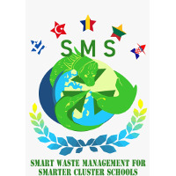
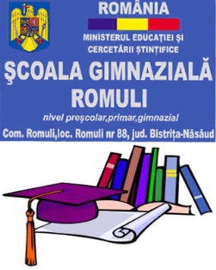

ERASMUS PROJECT: Smart Waste Management for Smarter Cluster Schools
PROJECT NUMBER: 2020-1-RO01-KA229-079971_5
DATE: 4^{th-} 8th of April 2022
Host: Romuli Secondary School
Number of participants: 25 students, 10 teachers

Reduce! Efficient use of resourcing for preserving the planet heritage - ROMANIA 2

DAY 1
07:30-08:30 – breakfast at the accommodation
9:00-10:30 - official reception, school visit and teams presentation
– implementing the “WasteMeter”- explaining the rules; students will collect plastic, paper and metal packaging during whole week, daily, in a special place, so that on Friday they can measure the total quantity and find out if it was collected correctly or not. At the end of each day/next day’s morning there will be a group of students named "Waste Warriors" (one from each country) who verify this and take some notes that will be visible for all people, near the recipients, up to the wall.
11:00-12:00 - “Be a smart collector”- the importance of reducing waste and the benefits of selective collection- presented by Cristian Niculae, the chief executive officer of the Inter-community Development Association for the Integrated Management of Municipal Waste from Bistrița-Năsăud county
13:00 – 14:00 – lunch at Hanul Tentea
14:30 – trip to Rodnei Mountains National Park - observing the natural resources of Romuli commune, visiting protected areas in the Rodnei Mountains National Park. The importance of reducing the consumption of wood, water and electricity.

DAY 2
07:30-08:30 – breakfast at the accommodation
09:00-10:00 - "Generation of change" - lesson about the national heritage of the county and protected area of Bistrița-Năsăud county, protected species (the viper, the motley tulip), the finite resources of the planet in our area and the effects of waste on the environment and presentation of the heating system of the school - from waste from forestry exploitation, as an example of good practices.
10:00-12:00 – workshop - creating postcards, ready to be sent it to the families with the message “Reduce waste!”
12:00 – 12:30 – lunch at Hanul Tentea
12:30 – “Water an inexhaustible resource?”- trip - case study on the shore of Lake Colibita (the place with the cleanest air in the country) - the legend of the lake and the study of the natural habitat of Vipera Berus, a type of protected viper in Romania
19:00/19:30- – dinner at Hotel Boutique Roser House, Colibita
DAY 3
07:30-08:30 - breakfast at the accommodation
09:00 – trip - experiential learning in the forest of Orheiul Bistritei to study the unique habitat of the Fritillaria meleagris, the motley tulip, protected species in Romania.
13:00 – outdoor lunch – a barbeque at a local farm
15:00 – Parliament debate – at the Bistrita-Nasaud Council – ‘’unlimited human needs versus limited natural resources-how can we balance them reported to planet equilibrium?”; the students will act like real life political figures in the Council’s meetings room; students will prepare their intervention before coming in mobility and they will play a role as in European Parliaments, representing their country and expressing their points of view.
16:30 – 17:30 – short walk in Bistrita, exploring the city downtown
19:30/20:00 – dinner at Hanul Tentea

DAY 4
07:30-08:30 – breakfast
09:00 – visit to the mayor’s office – presenting the office and the natural resources of Romuli
- piano performance – gave by the School’s Music teacher
10:00 – visit to the local church
10:30 – visit to the the important natural trout farm and restaurant – RIN restaurant and trout farm
13/14:00 – lunch at RIN restaurant
19:00 – intercultural dinner at Hanul Tentea

DAY 5
07:30-08:30 – breakfast
9:00 – closing ”WasteMeter” activity - it measures and centralizes how much garbage has accumulated this week. Responsible for the activity will be some students who are called "Waste Warriors" . They analyze the activity, draw conclusions and make recommendations.
11.00 - evaluation of the knowledge accumulated by the students - Kahoot test
12.00-ceremony for awarding diplomas of participation; exchange of souvenirs
13.00- electronic feed back questionnaire

